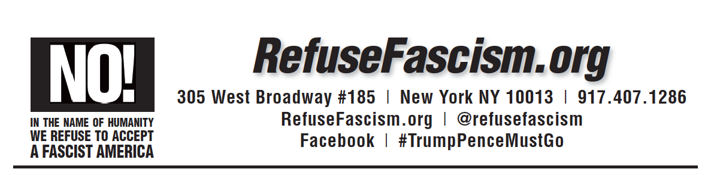

Dear
Recent weeks have seen a comprehensive and major escalation in the white supremacist ethnic cleansing of Black and Brown immigrants in this country. On March 5th, DACA is set to expire, putting nearly a million young people’s lives in jeopardy – meanwhile ICE has targeted leaders, conducted massive raids in sanctuary cities, and Trump ended TPS for a quarter of a million people.
This all-around assault on immigrants is not only a horror in its own right, it is the linchpin and battering ram of a whole fascist program being hammered into place by the Trump/Pence Regime. Trump’s “Wall,” along with this whole attack, is a potent symbol and instrument of terror that concentrates the shattering of old norms and cementing Trump’s new order of: “America First… Make America Great White Again.”
For this reason, RefuseFascism.org is initiating – and calling on you to endorse and join with – a mass day of protest and action on March 1 to stand against this vicious assault on immigrants. We call on you to spread the word among your networks to Wear Black on March 1, to stand up for all 11 million undocumented people by holding 11 minutes of silence on March 1 wherever people are, and to mobilize gatherings where possible.
Please read, endorse (by writing back to us), and spread the call for this mobilization below.
With urgency and determination,

on behalf of RefuseFascism.org

March 1: Immigrants Stay – Trump/Pence Must Go! Wear Black!
#ImmigrantsStayTrumpPenceMustGo
At work, at school, on the street:
Gather and hold 11 minutes of silence for all eleven million undocumented immigrants. These are our sisters and brothers!
Take pictures and spread them on social media using:
#ImmigrantsStayTrumpPenceMustGo!
Stand up against Trump’s comprehensive and white supremacist attacks on immigrants and immigration. Stand with DACA youth, with TPS recipients, with all those in detention right now. Stand with those whose families have already been torn apart and those who live each day with that fear. We will not sit by in silence.
In the name of humanity, we refuse to accept a fascist America!
To become an endorser of this nationwide day of protest, contact info@refusefascism.org or call 917-407-1286. RefuseFascism.org | @ RefuseFascism

